**Tutorial for using Facebook Live Vote**

Step 1-11 is required if this is the first time you use **this account** to make a Facebook Live Vote  
Step 12-17 is required if you have not install OBS Studio before.  
Skip to step 18 if you have installed OBS and used the same Facebook Account to make a Facebook Live Vote before.

1. Open any Internet Browser(preferably Google Chrome) and go to <https://developers.facebook.com/>
2. Click Login from right upper corner

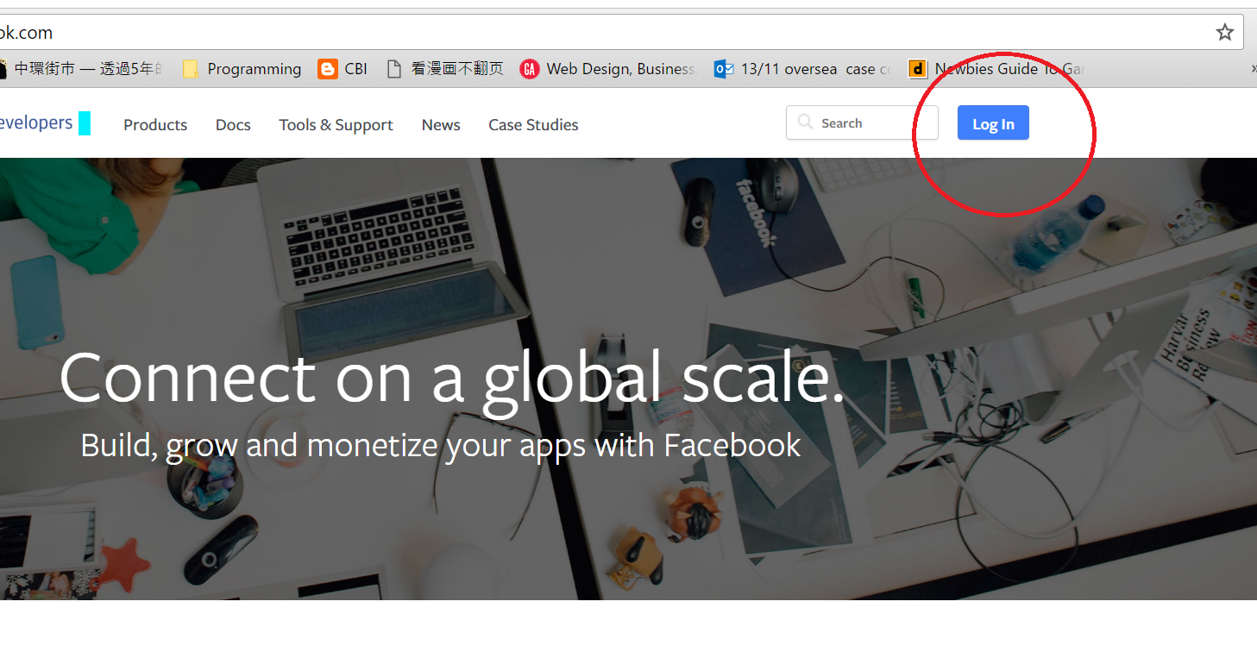

1. Enter the Email and Password that you will use for managing the Facebook page and live post.
2. After login, it should redirect you back to this page, if not, go to [https://developers.facebook.com/](https://developers.facebook.com/C) again. Now click My App, then click “Add a New App”

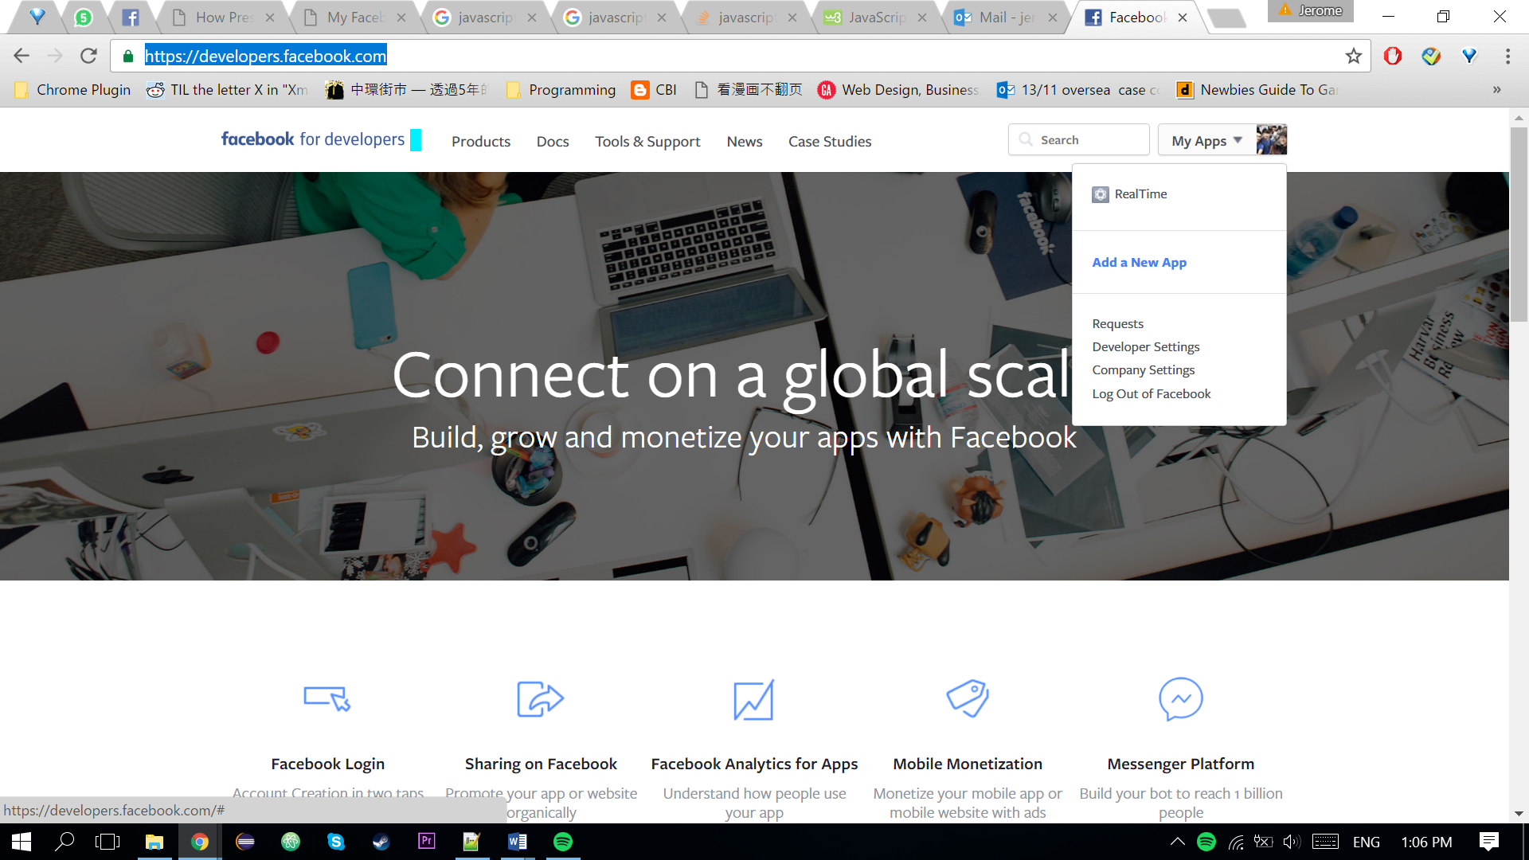

1. Any Display Name & Contact Email is okay, choose “Apps for Page” for Category is okay, then Click “Create App ID”, then you may need to pass through the security check.

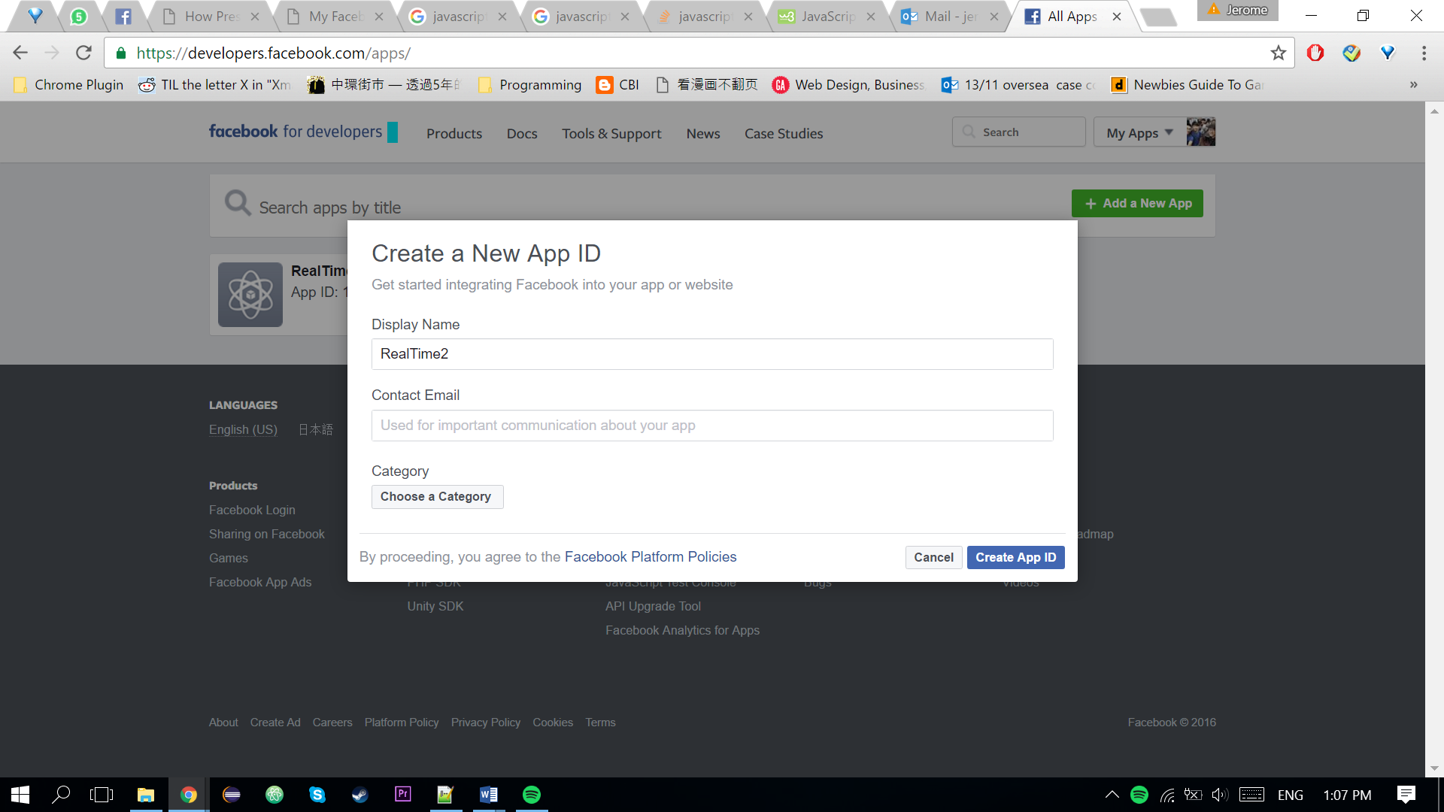

1. You will be redirected to the app page like the picture below, click App Review

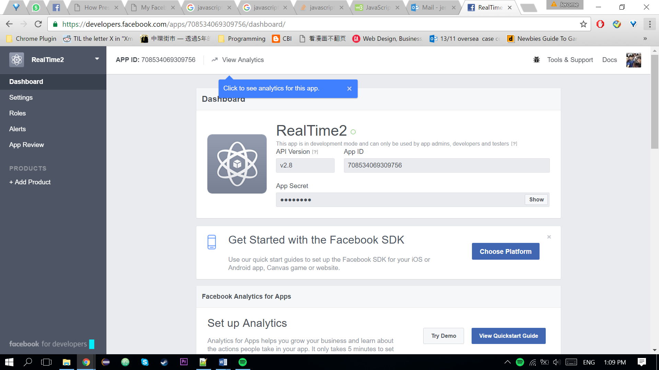

1. Choose “Yes” for the “Make App public?”

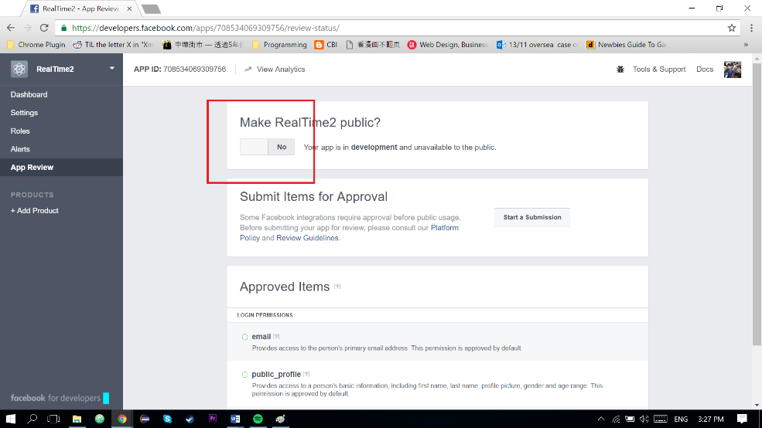

1. Go to <https://developers.facebook.com/tools/explorer/>, make sure you are logged in with the Correct Facebook Account.

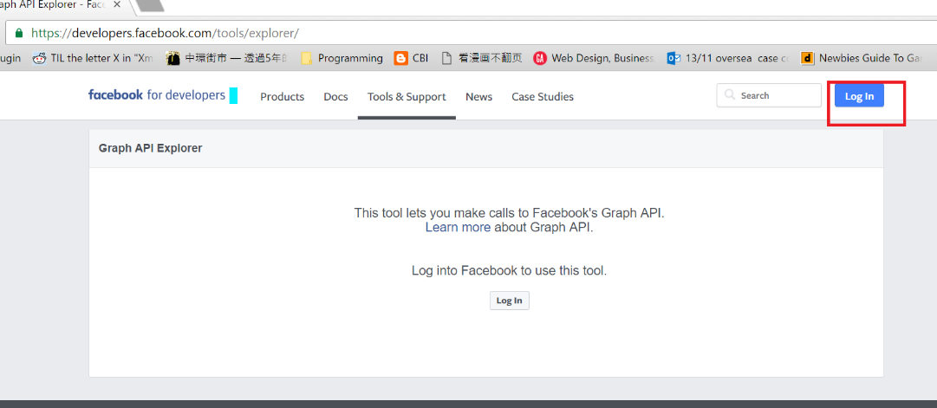

1. If you are logged in, this would be shown. Click the “Get token” button and click “Get User Access Token”.

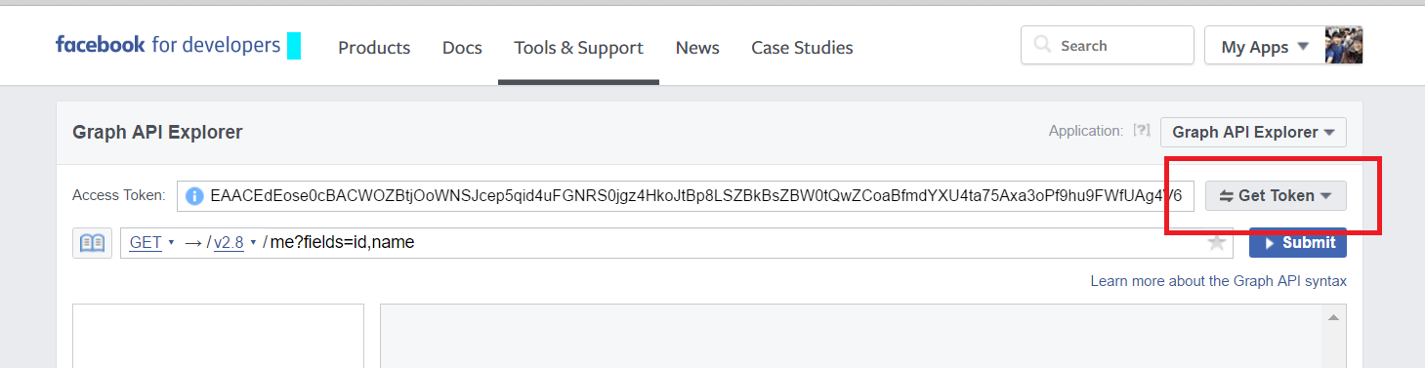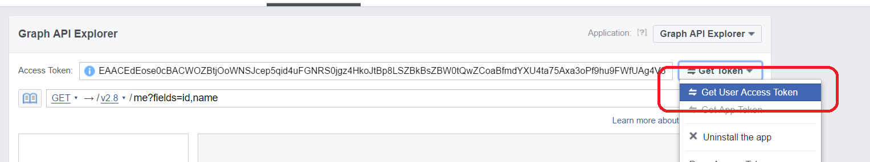

1. Just like the picture, tick the following:
   1. manage_pages,
   2. pages_manage_cta,
   3. publish_pages,
   4. user_likes,
   5. user_photos,
   6. user_posts,
   7. user_videos.

Then click the “Get Access Token” blue button

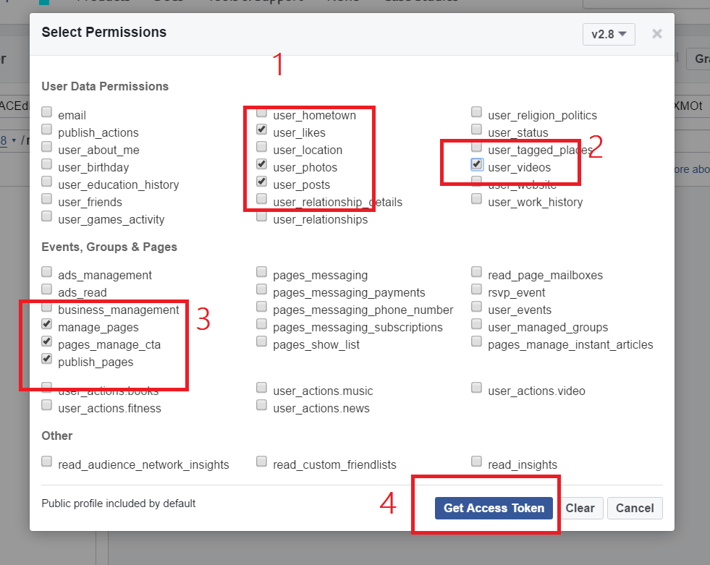

1. Click the “Continue as XXX” Blue button, then click “OK”.

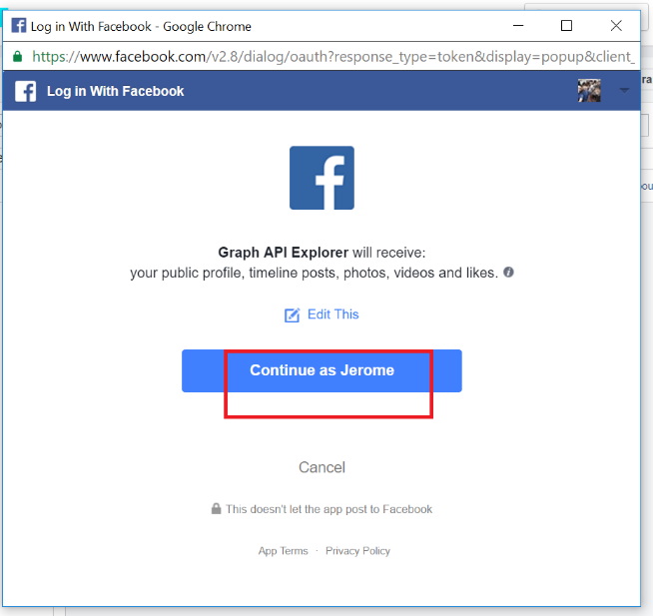 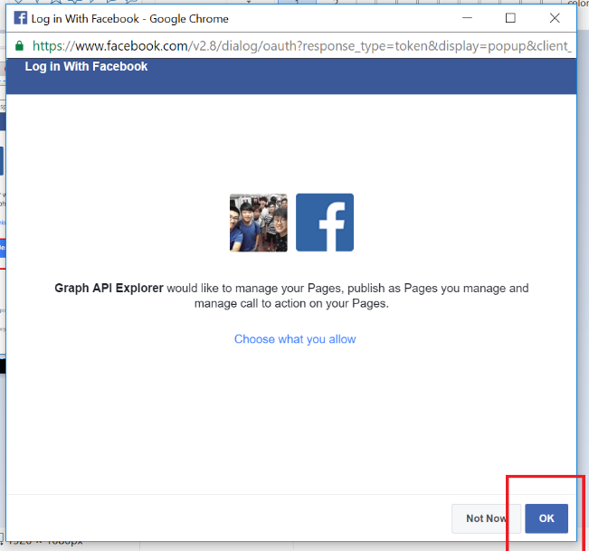

1. Go to <https://obsproject.com/download>
2. Choose your operating system correctly (Left Window, Middle Apple, Right Linux), then click the green button. 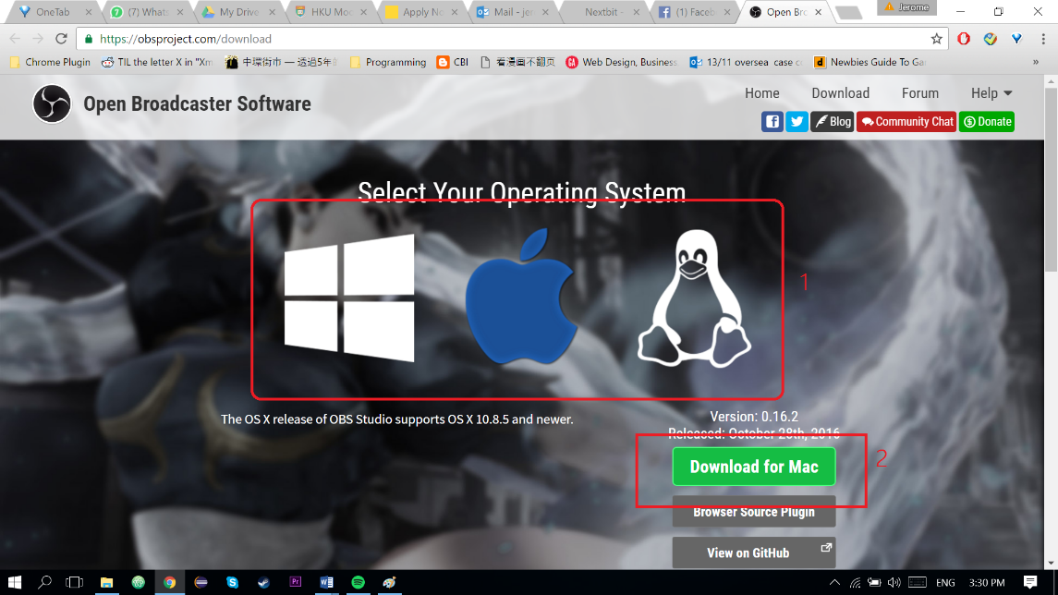
3. Wait it download and open the installer.

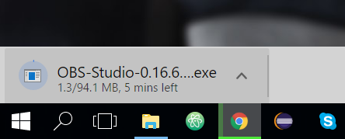

1. Click “Next” then “I Agree”

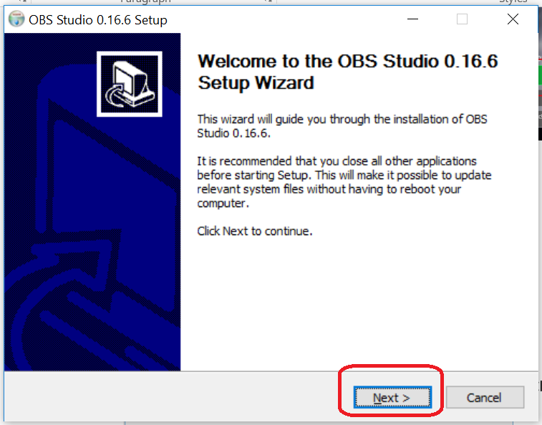 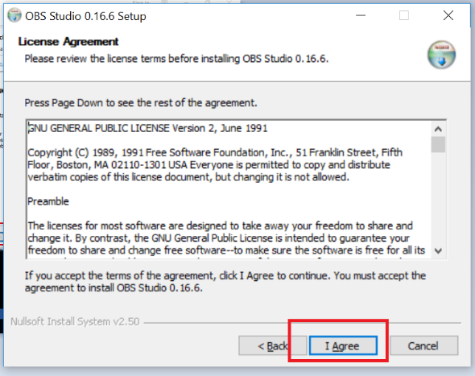

1. Select your destination folder (if you don’t know how to choose, just leave it as the default one), click “next” again. In the next page Just click “Install”

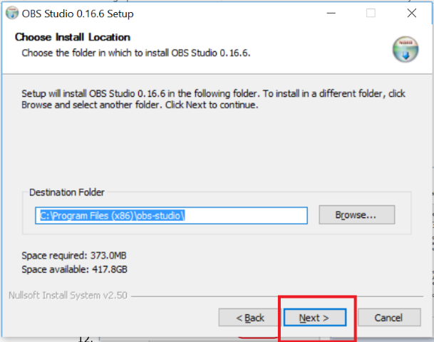 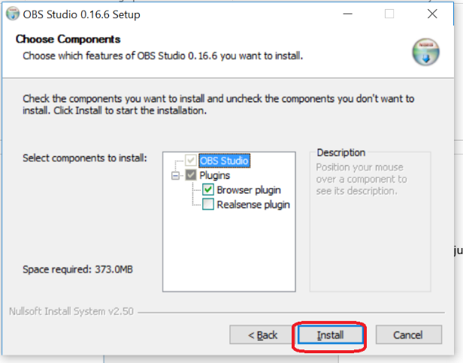

1. Tick “Run OBS Studio” and click “Finish”

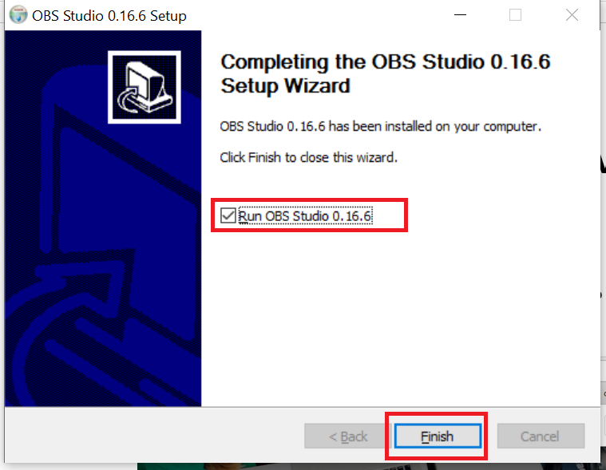

1. Go to <https://developers.facebook.com/tools/explorer/>, make sure you are logged in with the Correct Facebook Account which is the administrator of the corresponding Facebook Page.



1. Click the long “Access Token” bar which filled with random text, and copy it.

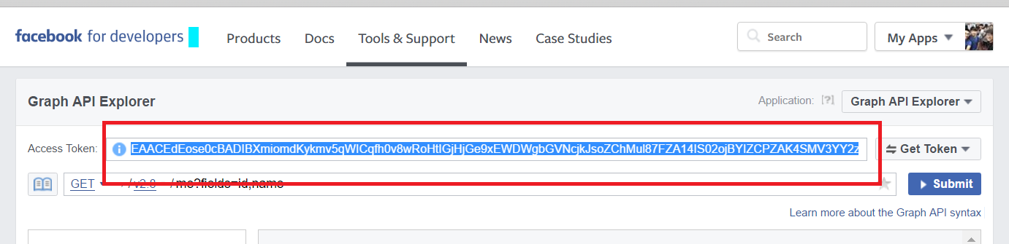

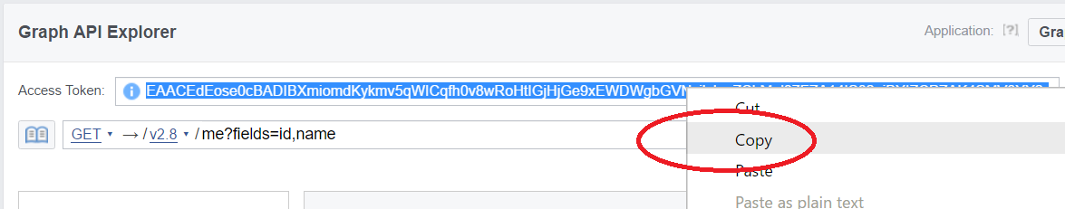

1. Open start.html with any Internet Browser (preferably Google Chrome) from the “Facebook Live Reactions” Folder.

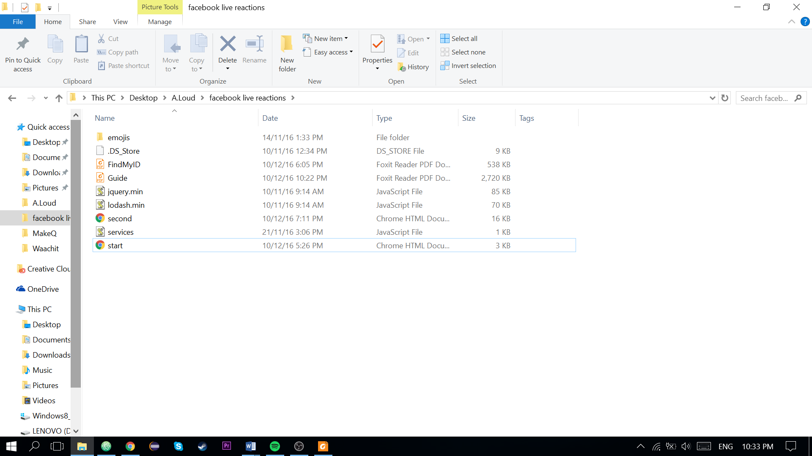

1. On the right hand side of the page, paste the “Access Token” you’ve just copied into “Application Access Token”
2. Copy the Personal ID or Page ID into the box too. (Refer to FindMyID.pdf if you don’t know how to find the ID)

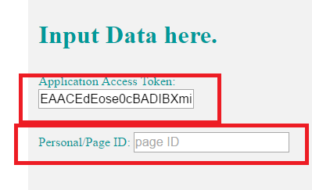

1. Choose the emoji you want to use and click Submit.

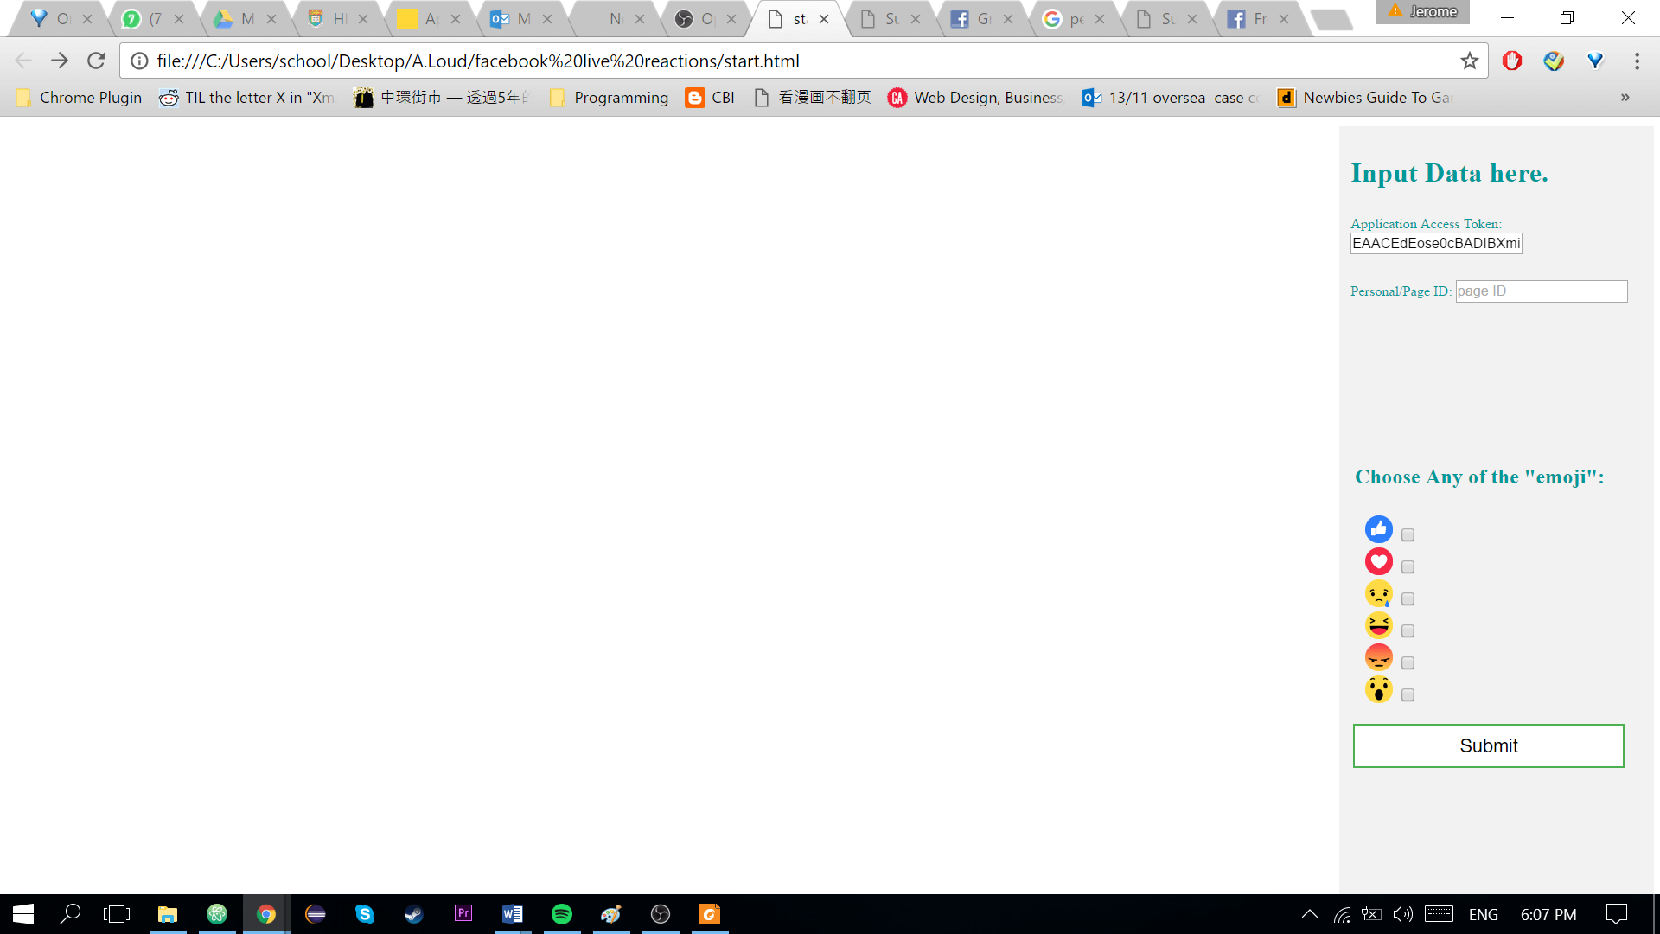

1. You will be redirected to the next page.

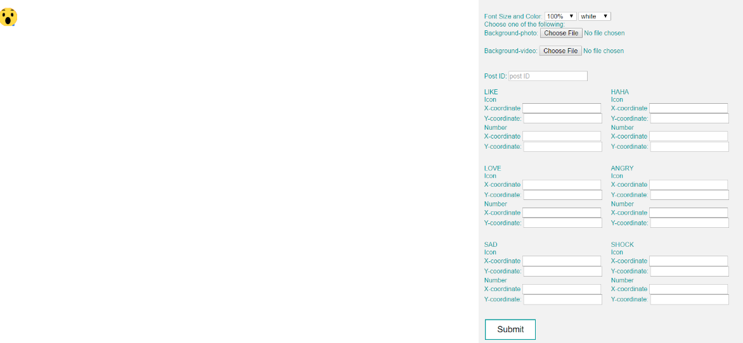

|  |
| --- |
| **Description of how it works:**  Font:  The default Font Size is very small, the default Font Color is also white, so you cannot see it. Adjust it as you like.  Background Photo and Video   * You can only choose **one** of them as background. * The background video will **auto-play and repeat** itself. * Both the size of the background photo and background video depend on the size of the browser. It will be adjusted **ONLY** **according to the width** of the background, so it depends on the width of the browser you are using (Just make sure the background won’t exceed the height of the browser). * Photo Format: **.png, .jpg/jpeg, .gif, .bmp**, others have not been tested (.tiff not working) * Video Format: **only .mp4** (.3gp, .avi is not working) * **BACKGROUND MUST BE OF 16:9 ratio** so there won’t be black border during streaming.   The Number refers to the number of the corresponding reaction.  For the X and Y coordinate, you need to input a number into it, it will auto update according to your number. (This may need some time.)  If there is any error, just click the refresh () button of the browser. |

Here is the suggested order of this page:

1. Choose the background first,
2. Then decide the size and color of the font
3. After that adjust the coordinate of the number and the icon
4. **DON’T CLICK SUBMIT YET AND LEAVE THE POST ID BLANK**
5. Open OBS Studio.
6. In the Scenes Box, **if there is no scene,** click “+” Button, and name it as you like, then click OK.

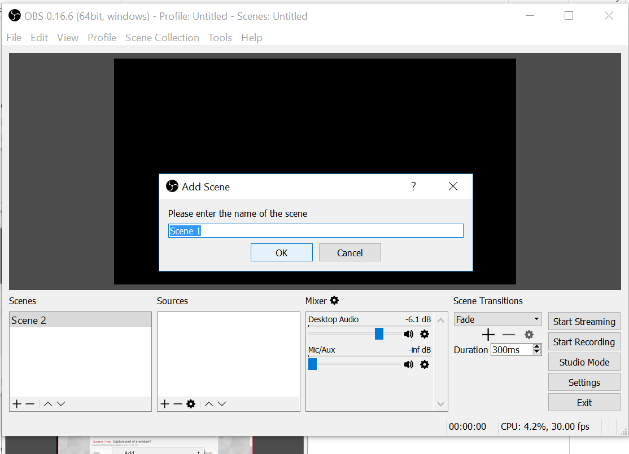

1. Now click the “+” button from Sources Box and choose “Window Capture”, select “Create New” and tick “Make Source Visible”.

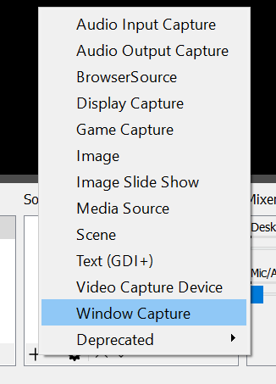 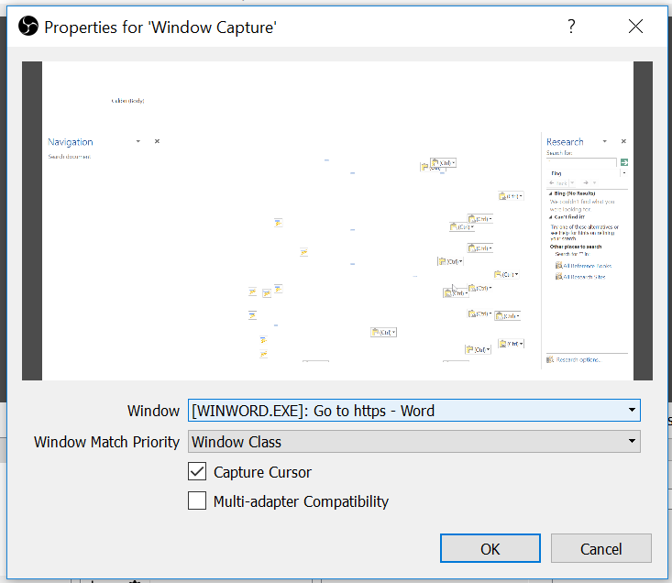

1. Select “[browser name]: second.html?........” for “Window”

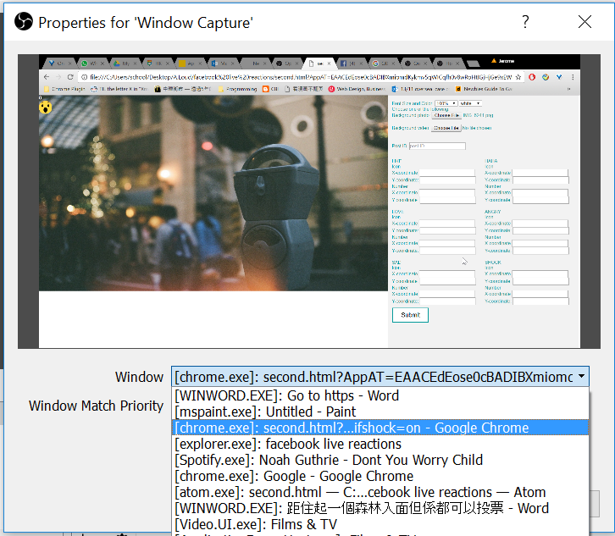

1. Unselect “Capture Cursor” so the cursor would not be shown, then click OK.

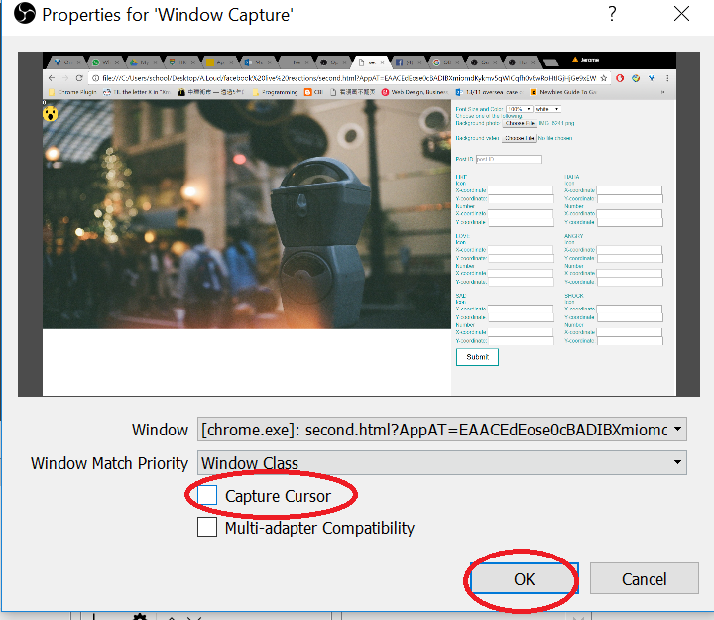

1. Now the whole browser will be displayed, you need to adjust the size accordingly so only the background would be shown. As you can see from the picture below, there’s a red border around it. Just drag and enlarge the photo so it cover all the black background and suits the whole screen.

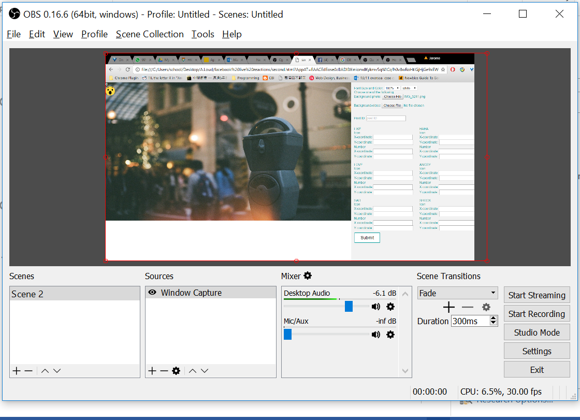

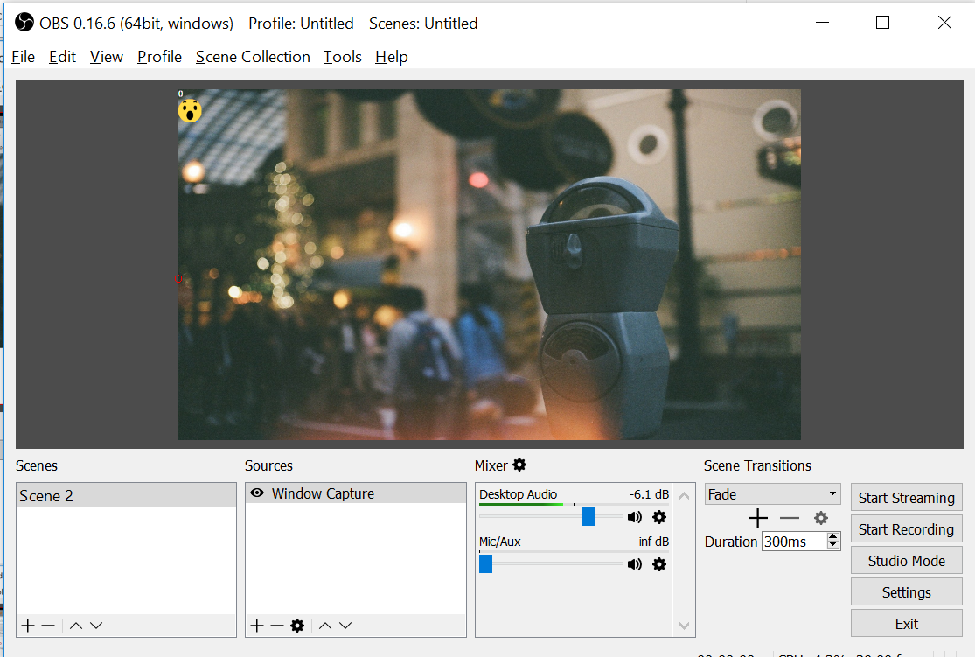

1. Now use the internet browser **IN NEW WINDOW** (shortcut key: Ctrl+N for Windows, ⌘+N for and go back to your Facebook, Create a live stream
   1. If you are streaming on your personal account, click this link (in a new window):

<https://iag.me/socialmedia/broadcast-computer-facebook-live/>

Then scroll down and click the blue button “Broadcast on Facebook Live”

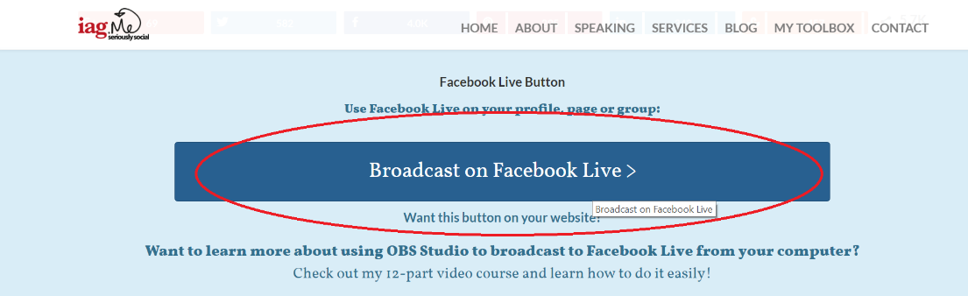

Then Click Next

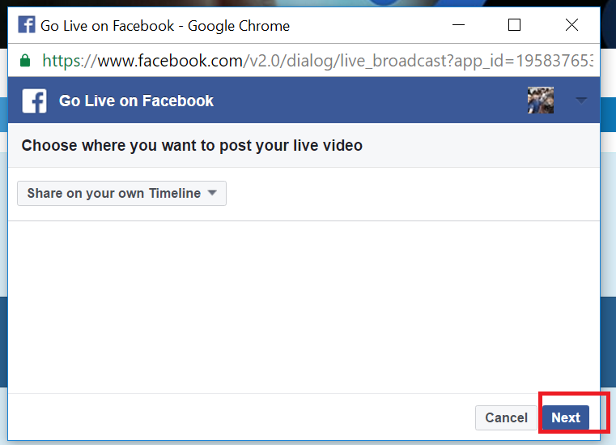

* 1. If you are streaming on a Facebook Page, go to your page and click the Publishing Tools from the Top Bar. (Remember using a new window of the browser)

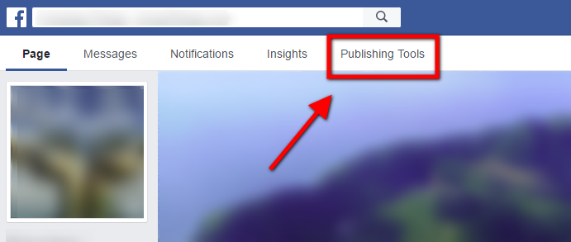

(For Page Streaming)Then Click “Videos” from the side bar" and select “Live”.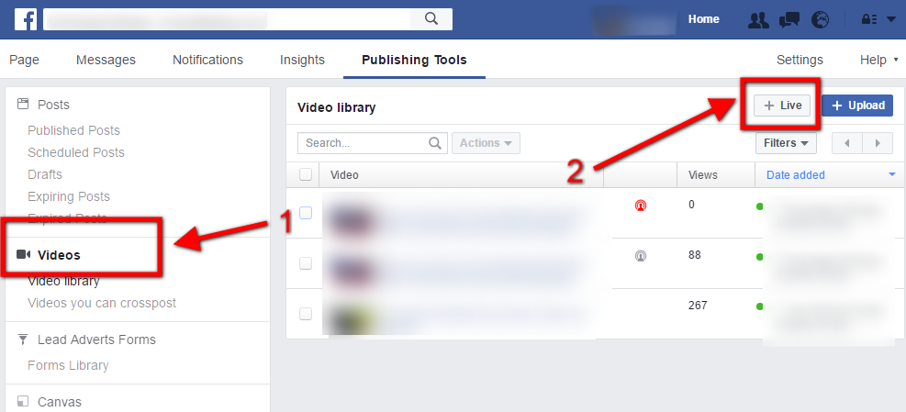

Then Click Next

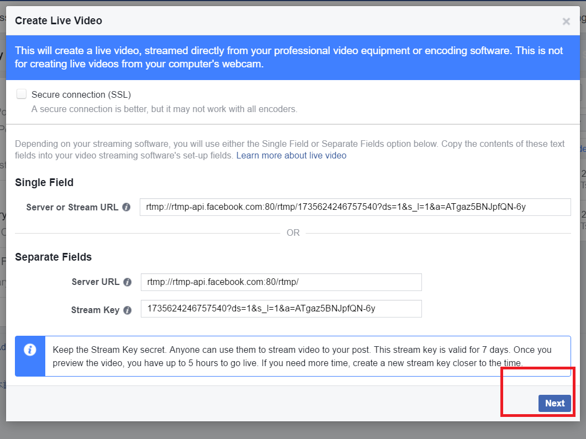

1. Type What’s on your mind and select the “Stream Key” tab.

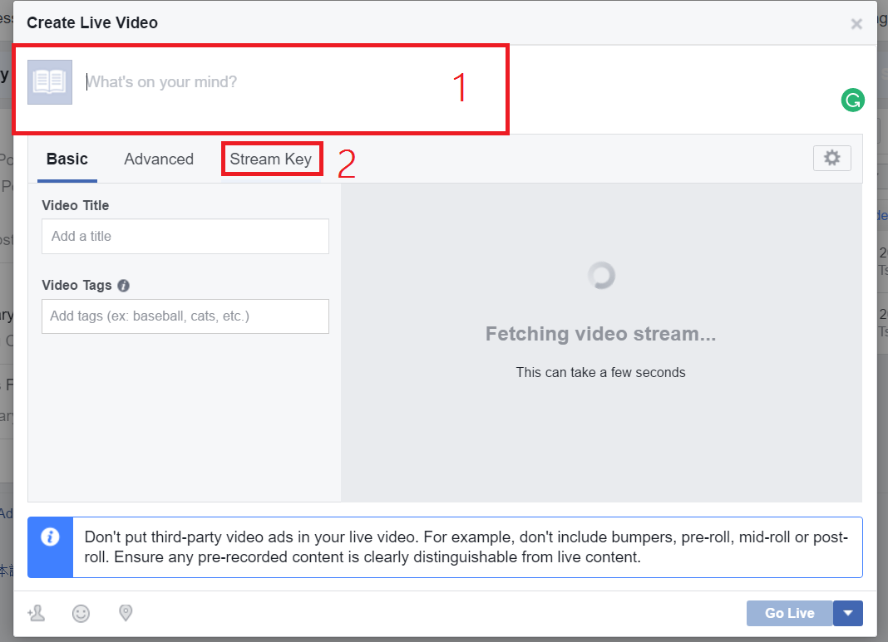

1. Tick “Secure Connection (SSL)” then copy “Stream Key”

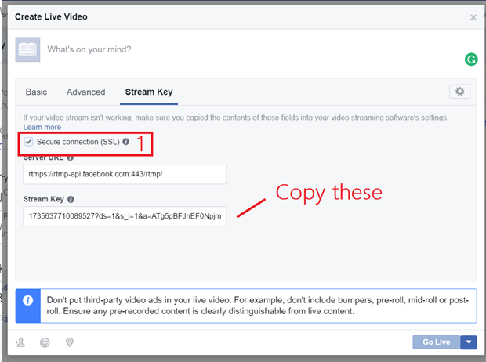

1. Back in OBS, click Setting, then select “Stream” from the side bar.

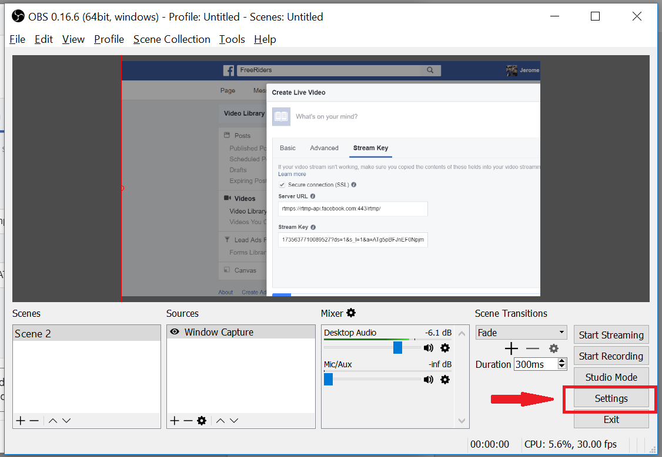

1. Follow the following setting then click OK:
   1. Stream Type: Streaming Services
   2. Copy the “Stream Key” from Facebook to “Stream key” of OBS Studio, then click OK

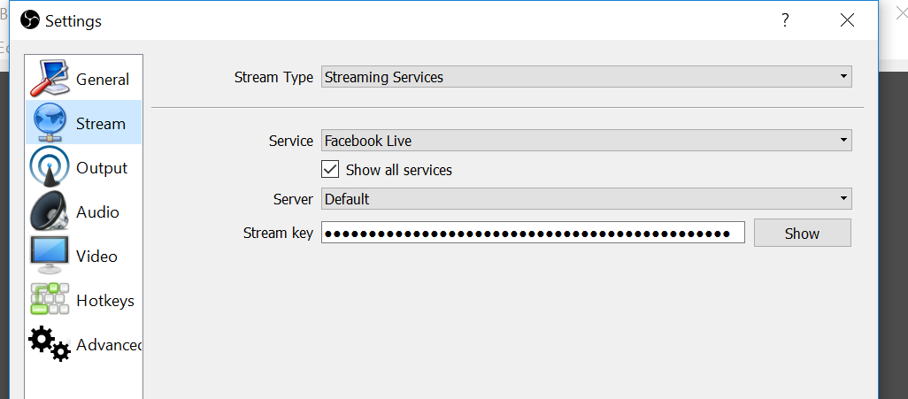

1. Click Start Streaming in OBS Studio.

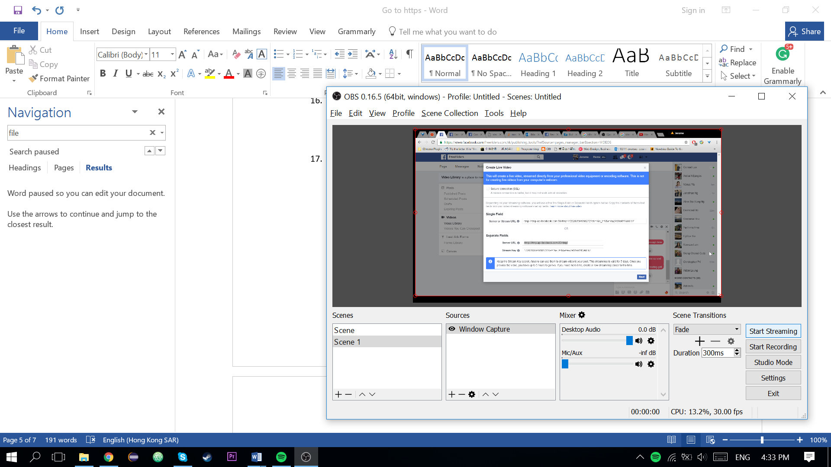

1. Go back to the Facebook Live Page and Click the Basic Tab to see if it works, it might take a few seconds. Then GO LIVE!!!

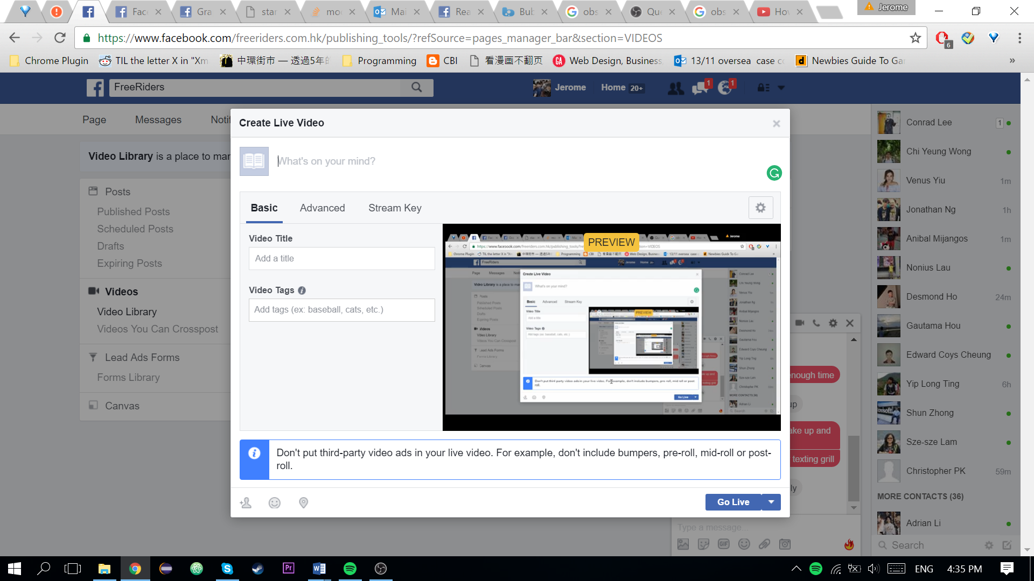

1. Yes, you haven’t type the Post ID Yet, now we are going to get it.

**This is important, DO NOT USE THE SAME WINDOW YOU OPENED THE HTML File TO BROWSE OTHER WEBSITE, KEEP IT IDLE.**

1. Now use the internet browser **IN NEW WINDOW** (shortcut key: Ctrl+N for Windows, ⌘+N for Mac) to get back to the Facebook Page, find the live post, now right click the time of the post.

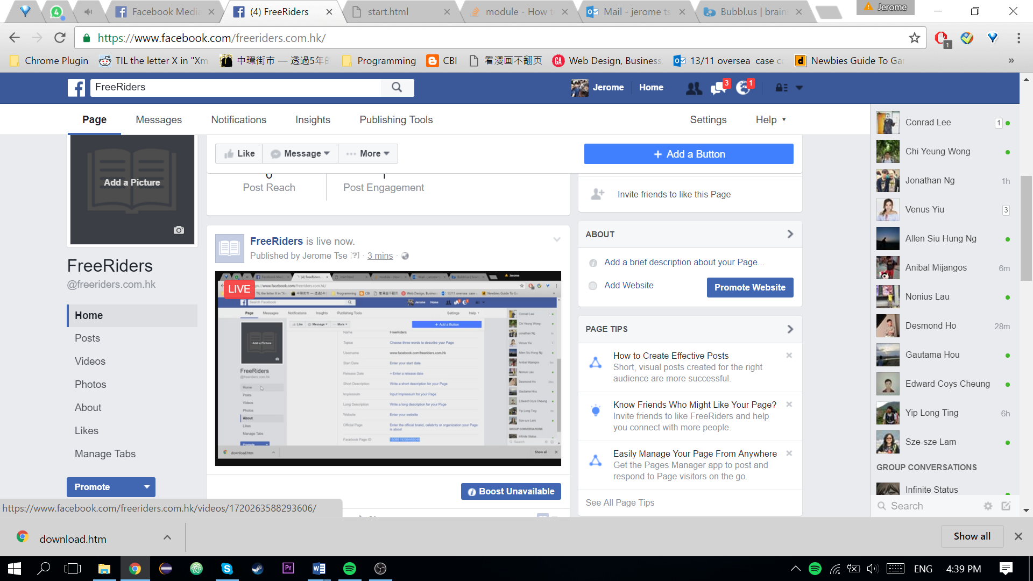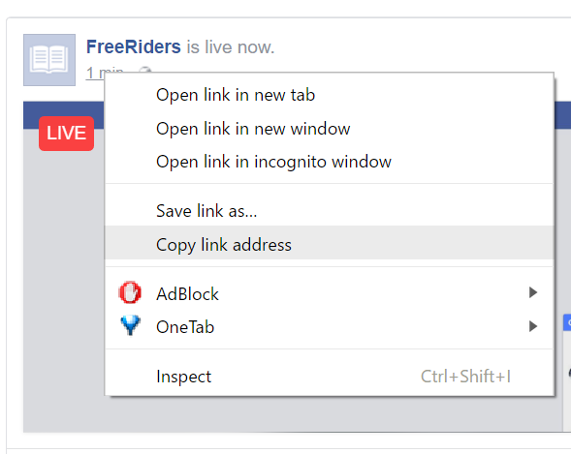

1. You will get something like this: **https://www.facebook.com/freeriders.com.hk/videos/1735637700089528/**

Now copy only the number after /videos/ (and remember to exclude the / afterwards)

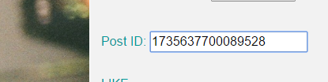

Now click submit. It will be automatically updated and done!